MONGODB BANKING MANAGEMENT SYSTEM
Project Report
Submitted By
- Name: Shourya Gupta
- Reg. no. 24BAI10801
- Course: FACE prep – Mongo DB
- College: VIT BHOPAL
Submitted To - Jaynath vellingiri
Academic Year
2025-2026

CERTIFICATE
This is to certify that the project titled "MongoDB Banking Management System" has been successfully completed by Shourya gupta as a part of the academic curriculum under the guidance of jaynath vellingiri

ACKNOWLEDGEMENT
I would like to express my sincere gratitude to my faculty guide and department for providing valuable guidance and support throughout the development of this project. Their suggestions and encouragement helped me successfully complete this project.

ABSTRACT
The MongoDB Banking Management System is a database-driven application developed using Python and MongoDB. The system manages customer records, bank accounts, employees, branches, and transactions. The application provides efficient storage, retrieval, and management of banking information through a structured database design.

All screenshots of my project banking management system
- Create_customer 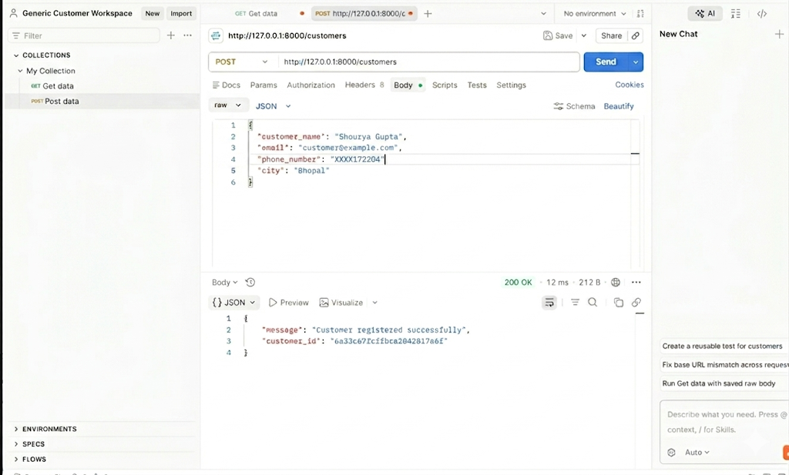

- Get_customer

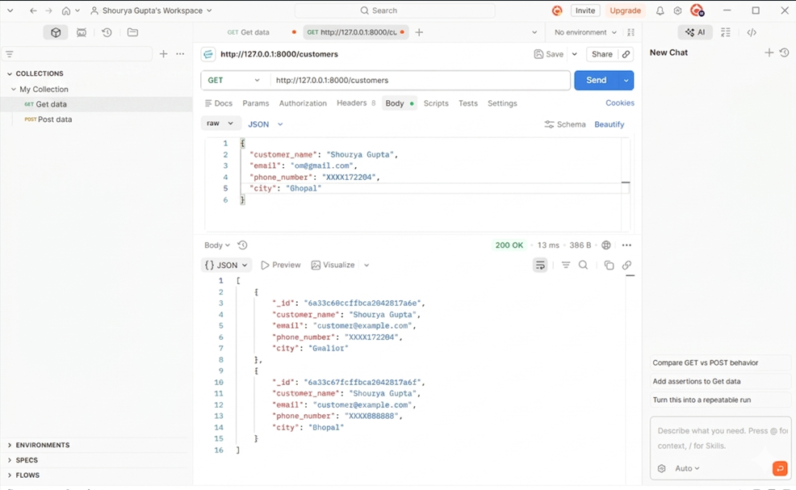

- Put_customer
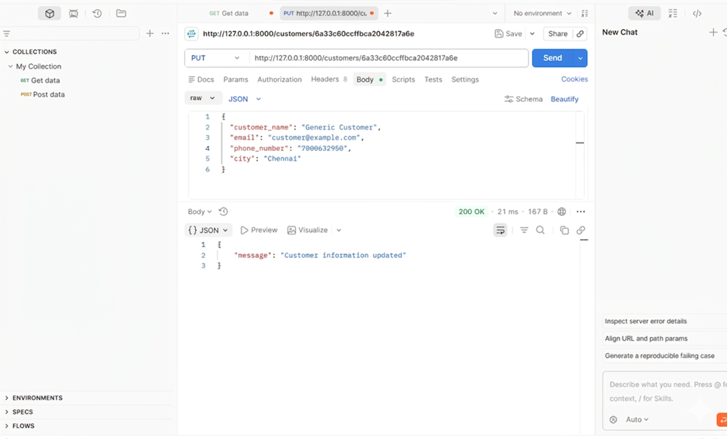

- Delete_customer
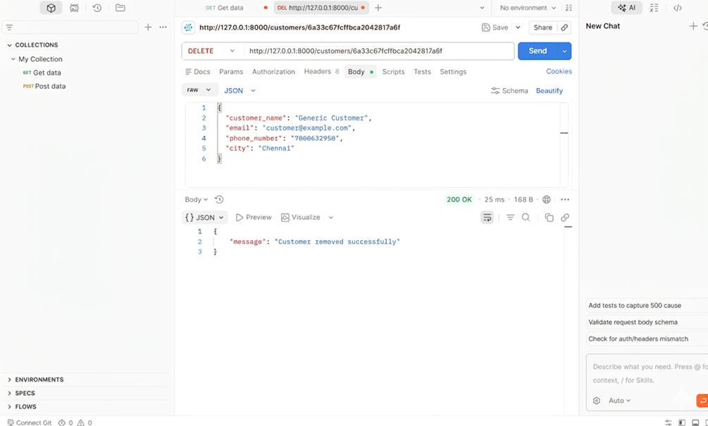

- Get_accounts
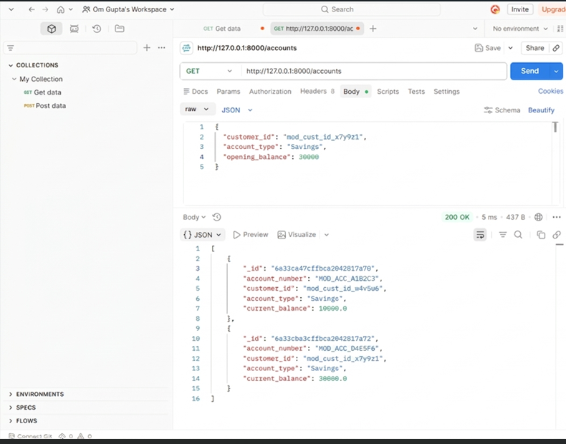

- Delete_account
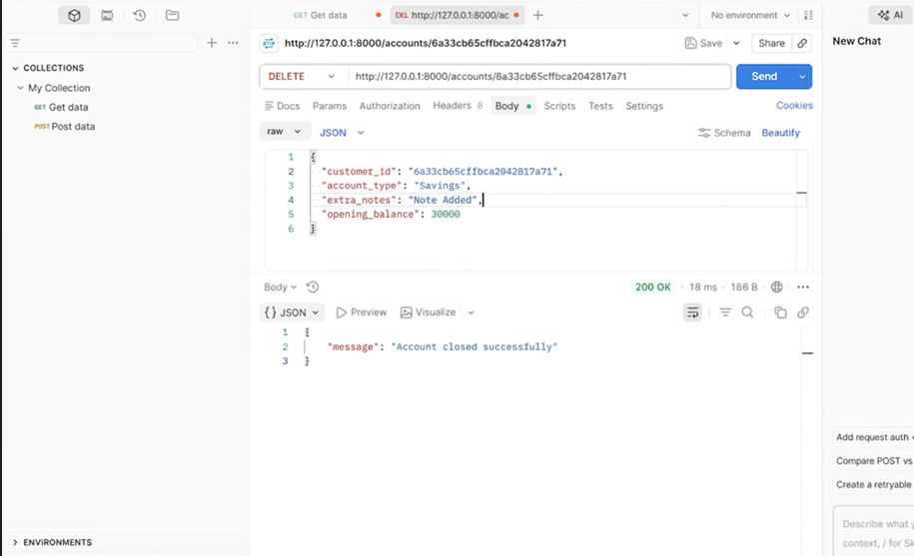
- Get_branch
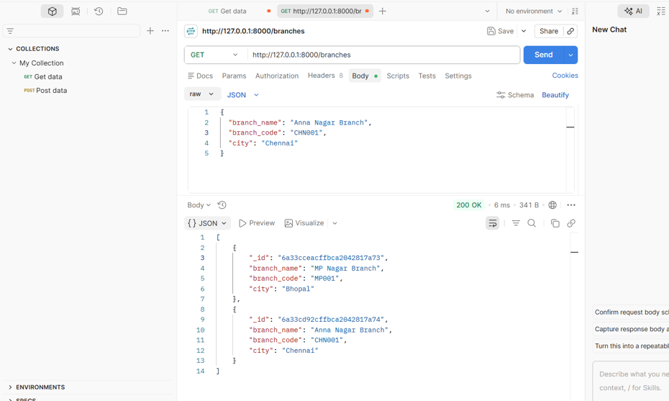

- Employee_creation
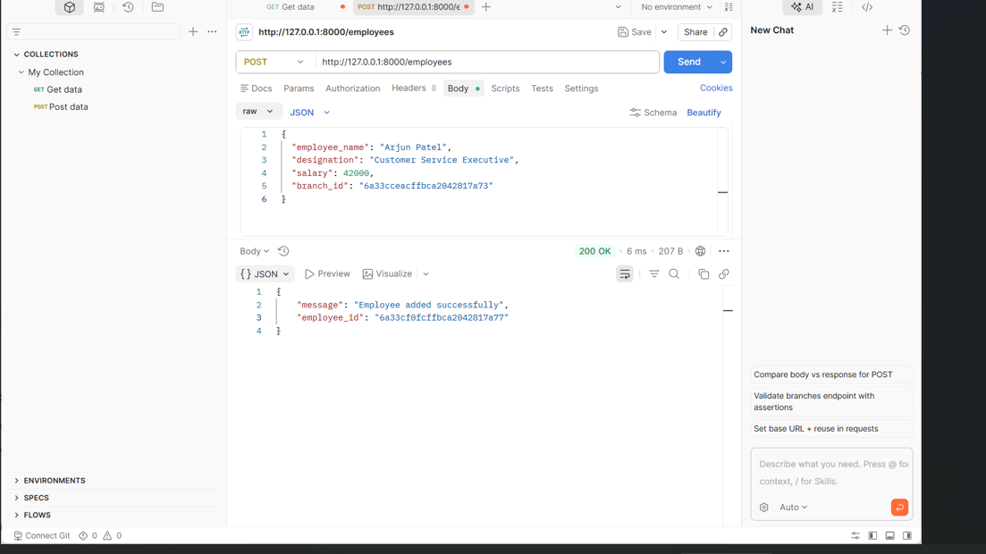

- Get_employee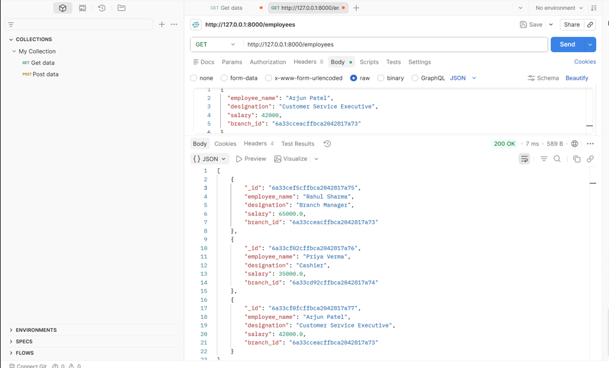
- Delete_employee
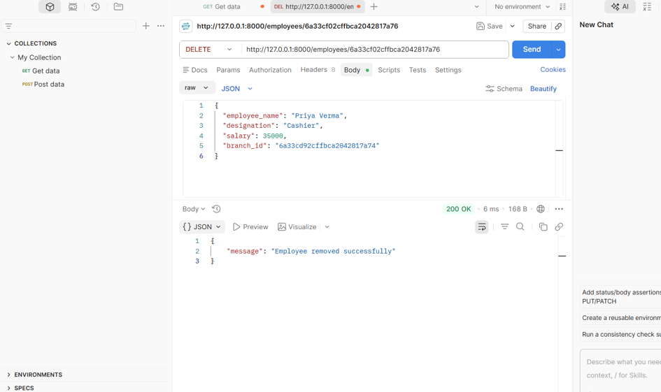
NOTE : rest of screenshots are attached in zip file only
Reason - file size
TABLE OF CONTENTS
- Introduction
- Objectives
- Software Requirements
- System Architecture
- Database Design
- Modules Description
- Implementation
- Testing
- Results
- Future Scope
- Conclusion
- References

1. INTRODUCTION
Banking institutions require efficient management of customer and transaction data. This project provides a centralized system for handling banking operations using MongoDB as the database backend and Python as the programming language.

2. OBJECTIVES
- Manage customer information.
- Manage bank accounts.
- Maintain employee records.
- Record banking transactions.
- Store branch information.
- Provide secure database connectivity.

3. SOFTWARE REQUIREMENTS
Hardware Requirements
- Processor: Intel i3 or above
- RAM: 4 GB or above
- Storage: 500 MB free space
Software Requirements
- Python 3.x
- MongoDB
- VS Code
- GitHub
- Windows 10/11

4. SYSTEM ARCHITECTURE
User
to
Python Application
to
MongoDB Database
to
Collections:
- Customers
- Accounts
- Employees
- Branches
- Transactions

5. DATABASE DESIGN
Customer Collection
Fields:
- customer_id
- customer_name
- phone_number
- email
- address
Account Collection
Fields:
- account_number
- customer_id
- balance
- account_type
Employee Collection
Fields:
- employee_id
- employee_name
- designation
Branch Collection
Fields:
- branch_id
- branch_name
- location
Transaction Collection
Fields:
- transaction_id
- account_number
- amount
- transaction_type
- transaction_date

6. MODULES DESCRIPTION
Customer Module
Handles customer creation, update, search, and deletion.
Account Module
Manages account opening and account details.
Employee Module
Stores employee information.
Branch Module
Maintains branch records.
Transaction Module
Stores and processes transaction data.
Module Database
Handles MongoDB connection and database operations.

7. IMPLEMENTATION
Programming Language: Python
Database: MongoDB
Main Files:
- main.py
- database.py
- customer_model.py
- account_model.py
- employee_model.py
- branch_model.py
- transaction_model.py

8. TESTING
Test Cases:
- MongoDB Connection Test
Result: Passed
- Customer Record Creation
Result: Passed
- Account Creation
Result: Passed
- Transaction Storage
Result: Passed

9. RESULTS
The application successfully performs banking data management operations and stores information in MongoDB collections efficiently.

10. FUTURE SCOPE
- Online banking integration
- Loan management module
- ATM management
- User authentication
- Mobile application support

11. CONCLUSION
The MongoDB Banking Management System demonstrates how NoSQL databases can efficiently manage banking information. The project successfully implements customer, account, employee, branch, and transaction management using Python and MongoDB.

12. REFERENCES
- MongoDB Official Documentation
- Python Official Documentation
- GitHub Documentation
- Database Management System Notes

THANK-YOU

